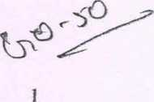

IN THE HIGH COURT OF KARNATAKA AT BANGALORE Dated this the 19th day of July 2011 PRESENT
THE HON’BLE MR.J.S.KHEHAR, CHIEF JUSTICE
AND
THE HON’BLE MR.JUS71CE ASHOK B.HINCHIGERI
WRIT PETITION No. 10955/201 I fGM-RES-PIL)
Between:
- The National Federation of the Blind Having its Registered Office at:
Plot P.21, Sector 6
M.B.Road, Pushpavihar
New Delhi 110 017
And its Bangalore branch Office at:
No. 18, 14th Cross, Cholorupalya Bangalore-23.
Represented by its General Secretary Mr.Nagaraj.
- Mr.Basavaraj K.N.
S/o.Mr.Nijaanandaiah Aged 23 years
Residing at Kodihalli Village Kotenayakanahalli Post Kasaba Hobli, Tiptur Taluk Tumkur District 572 201.
- Mr.Santhosha Basavaraja Chalavadi S/o.Mr.Basavaraja Chalavadi Aged 20 years
Residing at No. 1436, Ward No.2 Netaji Nagar, Muddebihal Taluk Bijapur 586 212. ...Petitioners
(By Ms.Jayna Kothari, Adv.)
And:
The Karnataka Public Service Commission Udyoga Soudha Bangalore 560 OOP Represented by its Chairman.
And copying received
- 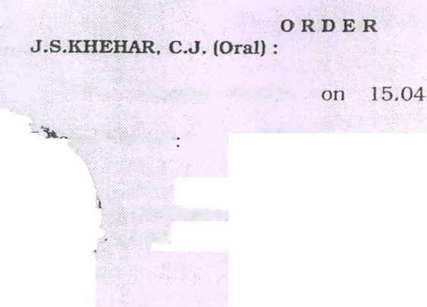The Secretary
Department of Personal and Administrative Reforms State Government of Karnataka No.32, Vidhana Soudha Bangalore 560 001.
- The State Government of Karnataka
Department of Women and Child Welfare M.S.Building Bangalore 560 001
Represented by its Principal Secretary.
- The Commissioner for Diasbilities No.40, Thambuchetty Road Cox Town
Bangalore 560 005. ....Respondents
(By Mr.Reuben Jacob, Adv. for Rl, Mr.
R.Devdas, AG A for R2 to 4)
This Writ Petition is filed under Articles 226 and 227 of the Constitution of India praying to direct the respondents to set aside the order passed in the Writ Petition No.40405/1999 dated 16.10.2000. aside the notification dated 2.2.2011 No.E(3)1714/10-11 PSC produced as Annexure G herein, to the extent that it bars persons who are blind and with low vision from being considered for the post of Junior Assistant/Second Division Assistant, to bring it in conformity with the persons with Disability (Equal Opportunities, full Participation and Protection of Rights) Act, 1995 and the Karnataka Civil Services Recruitment Rules, 1977 and etc.,.
This Writ Petition corning on for further consideration this day, Chief Justice made the followingr
The motion bench,
jving order
“It is the contention of the learned counsel for e petitioner, that through a notification dated .02.2011, applications were invited to fill up the
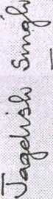posts of Assistants/First Division and Junior Division/Second Division. However, while providing reservation under the provisions of the Persons with Disabilities (Equal Opportunities, Protection of Rights & Full Participation) Act. 1995, no reservation was provided for blind or law vision persons. It is the submission of the learned counsel for the petitioners, based on a notification dated 02.02.201 J. that for similar posts, the Central government provides reservation, even for blind and low’ vision persons. Additionally, learned counsel for the petitioners invited our attention to a notification dated 15.03.2007 (Annexure-M) wherein, for posts where the duties and responsibilities are of the same nature, as the posts of junior assistants/second division assistants and assistants/first division Assistants, reservation has been provided for blind and low vision persons. The action at the hands of respondents, according to the learned counsel for the petitioners, in not providing reservation in the impugned notification dated 02.02.2011, is arbitrary.
In the peculiar facts and circumstances of the case, we consider it just and appropriate to require respondent nos.2 to 4 to take a fresh decision on the issue in hand, in respect of the two posts referred to hereinabove. The aforesaid decision will be taken, keeping in mind the basis of the submission advanced at the hands of the learned counsel for the petitioners, as has been narrated in the foregoing paragraph.
We are informed, that the selection process for the advertised posts will commence only in July 2011.
In order to prevent any further delay in the process of selection, we consider it just and appropriate to direct respondent no. 1 to issue a corrigendum to the notification dated 02.02.2011 so as to invite applications for the posts referred to hereinabove, even from blind and low vision persons. The aforesaid corrigendum shall be issued by respondent no. 1 positively within two weeks from today. Needless to mention, that respondent no. 1, while issuing the aforesaid corrigendum, shall expressly indicate, that the right of such blind/low vision persons for
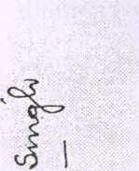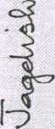
posts of Assistants/First Division and Junior Division/Second Division. However, while providing reservation under the provisions of the Persons with Disabilities (Equal Opportunities. Protection of Rights &. Full Participation) Act. 1995. no reservation was provided for blind or law vision persons. It is the submission of the learned counsel for the petitioners, based on a notification dated 02.02.2011. that for similar posts, the Central government provides reservation, even for blind and low vision persons. Additionally, learned counsel for the petitioners invited our attention to a notification dated 15.03.2007 (Annexure-M) wherein, for posts where the duties and responsibilities are of the same nature, as the posts of junior assistants/second division assistants and assistants/first division Assistants, reservation has been provided for blind and low vision persons. The action at the hands of respondents, according to the learned counsel for the petitioners, in not providing reservation in the impugned notification dated 02.02.2011, is arbitrary.
In the peculiar facts and circumstances of the case, we consider it just and appropriate to require respondent nos.2 to 4 to take a fresh decision on the issue in hand, in respect of the two posts referred to hereinabove. The aforesaid decision will be taken, keeping in mind the basis of the submission advanced at the hands of the learned counsel for the petitioners, as has been narrated in the foregoing paragraph.
We are informed, that the selection process for the advertised posts will commence only in July 2011. In order to prevent any further delay in the process of selection, we consider it just and appropriate to direct respondent no. 1 to issue a corrigendum to the notification dated 02.02.2011 so as to invite applications for the posts referred to hereinabove, even from blind and low vision persons. The aforesaid corrigendum shall be issued by respondent no. 1 positively within two weeks from today. Needless to mention, that respondent no. 1, while issuing the aforesaid corrigendum, shall expressly indicate, that the right of such blirid/Iow vision persons for

selection and appointment would be subject, to the decision to be taken by this Court, in the present writ petition.
In the meantime, respondent nos.2 to 4 shall take a decision in the matter one way or the other within eight weeks from today. The expert committee shall be constituted by the competent authority within two weeks from today.
A copy of this order shall be furnished to both the learned counsel representing the respondents under the signature of the Court Officer attached to this Bench."
In furtherance of the aforesaid order, the State Government has issued notification dated 10.06.201 1 wherein the posts of First Division Assistant/Assistant. Second Division Assistant/Junior Assistant, have been included in Col. nos.3 and 4 pertaining to the departments mentioned in Col.2.
3. In view of the aforesaid notifications, such of the
blind/low vision persons who had responded to the corrigendum issued by the Karnataka Public Service Commission must be deemed to have acquired eligibility for consideration for the advertised posts. Candidates who had responded to the aforesaid corrigendum are accordingly ble to be considered against the ^advertised posts. Before e aforesaid exercise is carried out, the reservation for
blind/low vision persons shall be determined for the posts under reference, in terms of the provisions of the Persons with Disabilities (Equal Opportunities, Protection of Rights & Full Participation) Act, 1995 and the orders passed by the State government. The said posts shall be filled up based on the said reservation for blind and low vision persons.
- The instant writ petition is disposed of in the aforesaid terms.
Sd/-
Chief Justice

